
Science Inquiry (I)
In this strand, teaching and learning explores ‘how’ we investigate the world. This includes posing questions, planning and conducting investigations,
collecting, analysing and evaluating data, drawing evidence-based conclusions, communicating findings, and using appropriate tools and technologies.

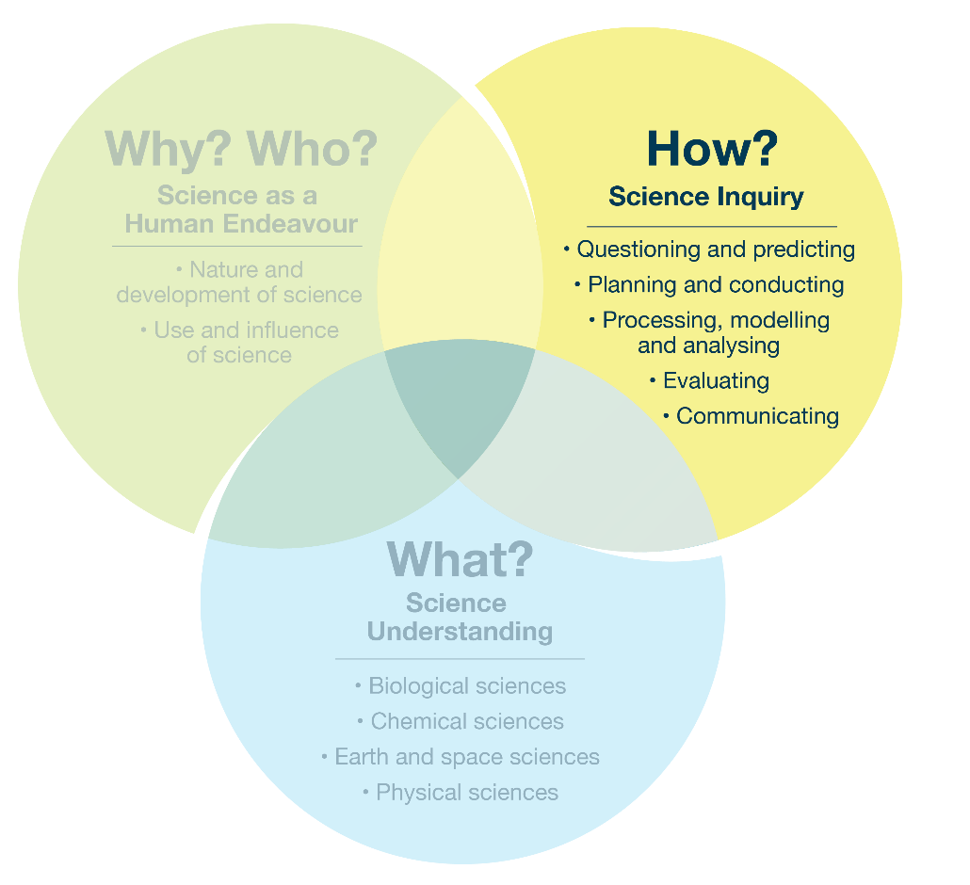
Focus 1.3 – The Science Inquiry strand and sub-strands

Example topic – single strand
Students could work in groups to conduct experiments investigating how different environmental factors affect plant processes, making notes about their findings and communicating their results clearly.
Possible focus questions | Curriculum alignment
What questions and predictions can we make about how plants absorb water through their roots and how sunlight affects their growth? | Sub-strand: Questioning and predicting
How can we plan and conduct experiments to test the effects of sunlight and soil type on plant growth and water absorption? | Sub-strand: Planning and conducting
How can we analyse and evaluate our data on plant growth and water absorption, and effectively communicate our conclusions to others? | Sub-strands: Processing, modelling and analysing; Evaluating; Communicating

